SimplyFly Flight Booking Web – Wireframes

SCREEN 1 — LOGIN / ROLE SELECTION (RBAC)

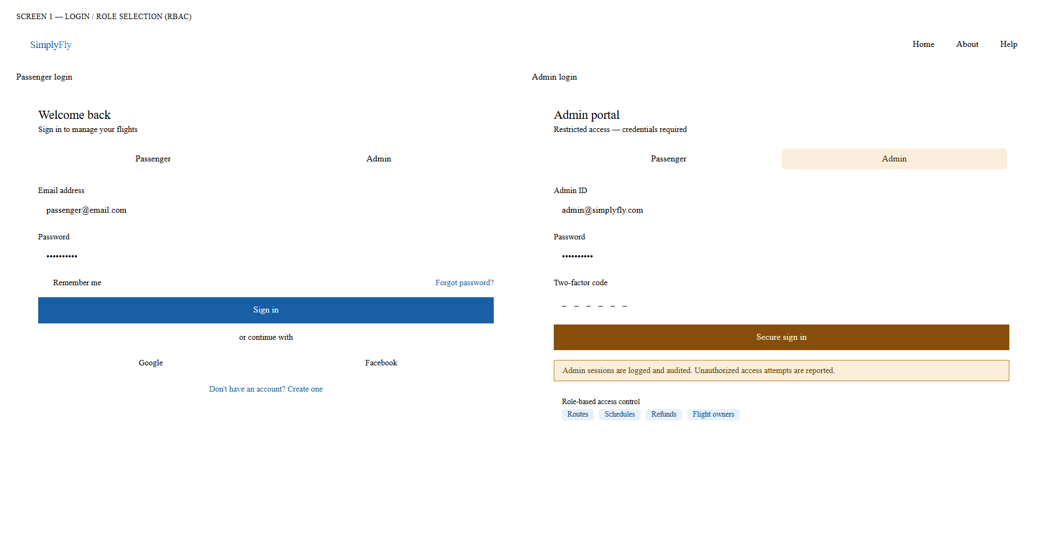

SCREEN 2 — USER DASHBOARD: FLIGHT SEARCH & RESULTS

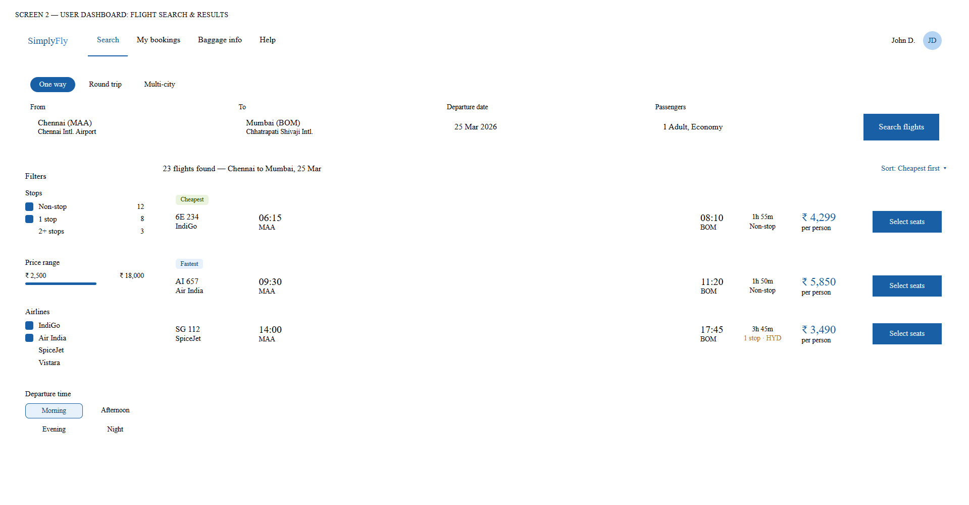

SCREEN 3 — SEAT SELECTION & BOOKING

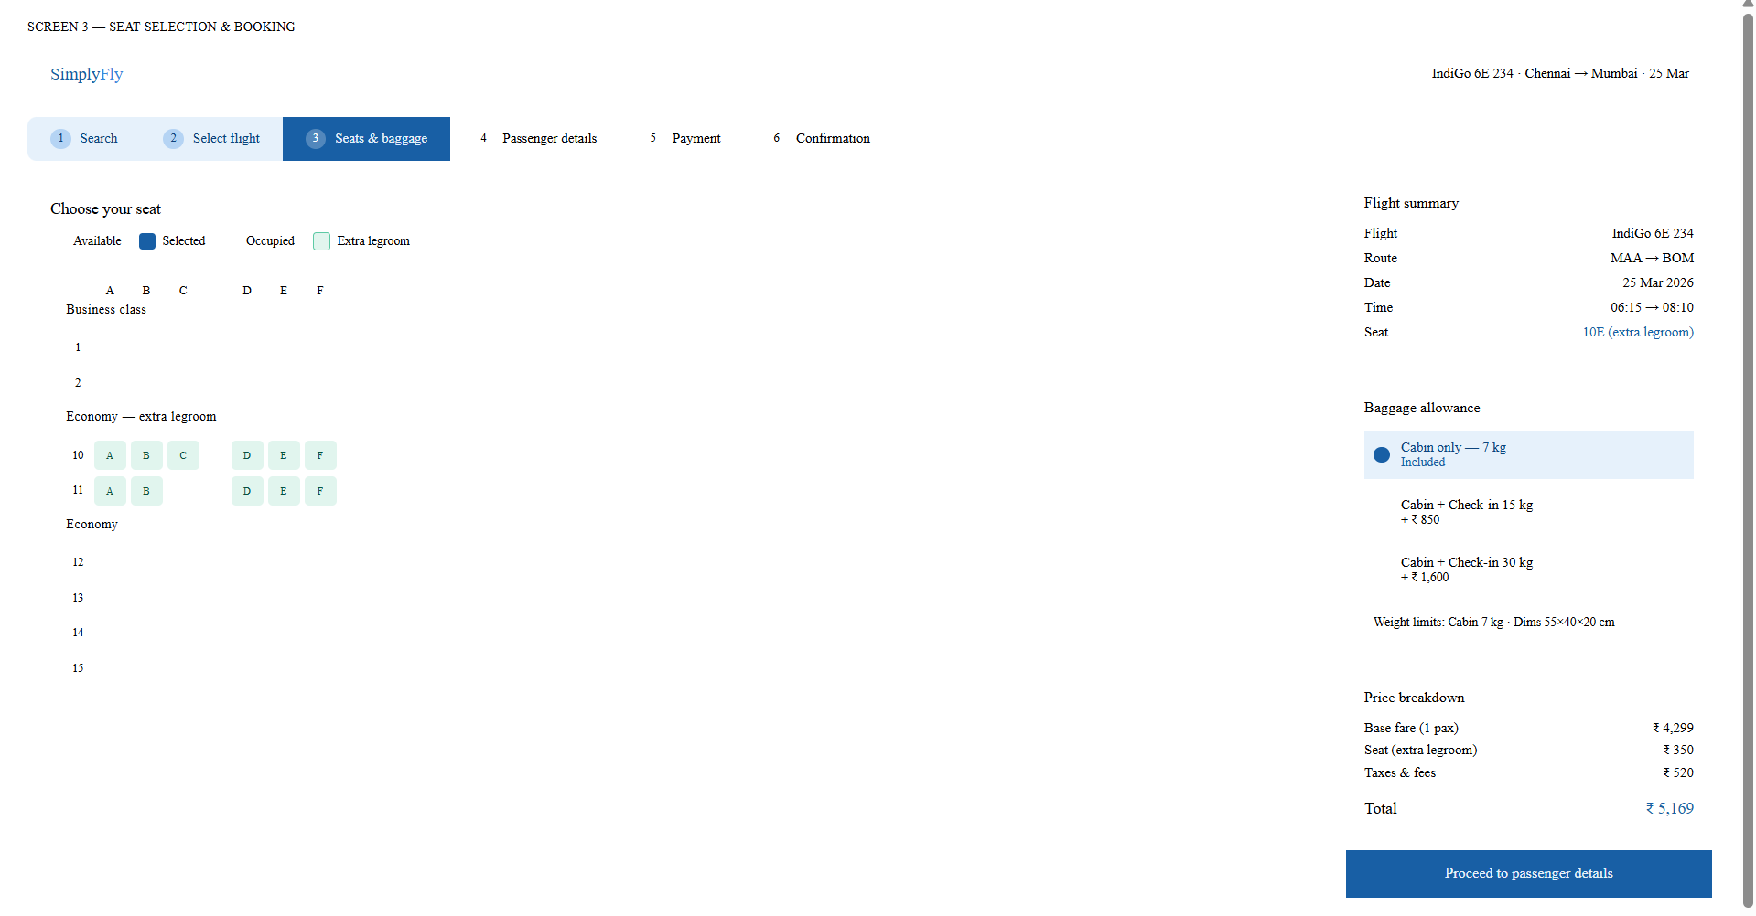

SCREEN 4 — MY BOOKINGS, E-TICKET & CANCELLATION

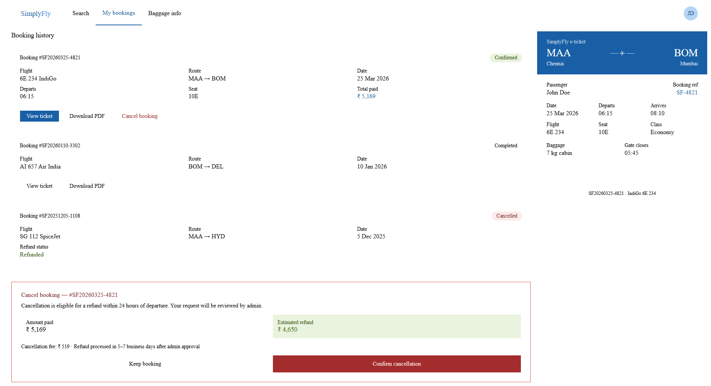

SCREEN 5 — ADMIN DASHBOARD

